4-Port High-Speed USB2.0 Hub
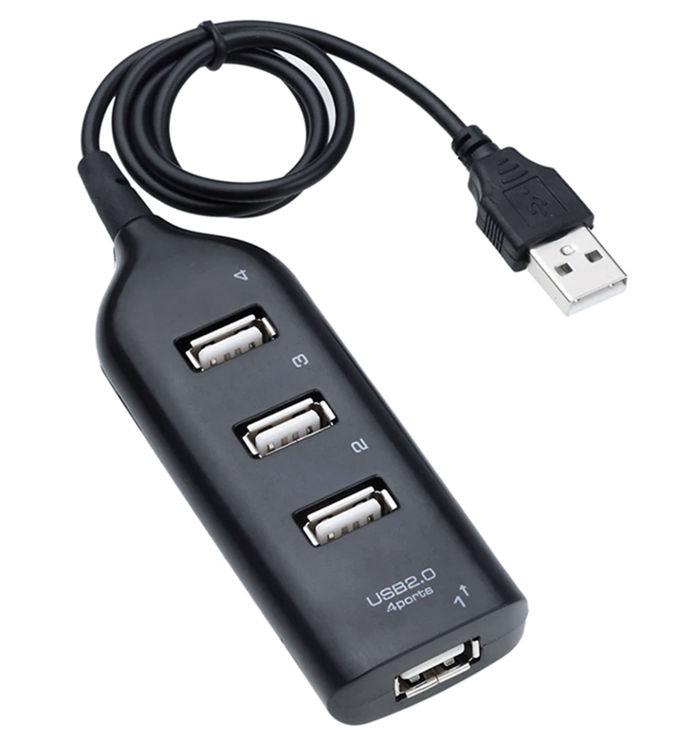

FEATURES
• 4-Port High-Speed USB Hub
• Up to 480Mbps Transfer rates
• USB2.0 and Backward USB1.1 compatible
• Compact, self-powered design
• Add extra USB ports to your Computer
• Ideal for iPod™, Printers, Cameras and any other USB device
• Fully Plug n’ Play – Just plug in and go
• Overload protection and status LEDs
• For Windows™ and MAC™

Connect a USB Printer, Scanner, External Disk Storage or iPod™ with

this Compact and convenient high-speed USB2.0 Hub giving you 4

extra USB ports

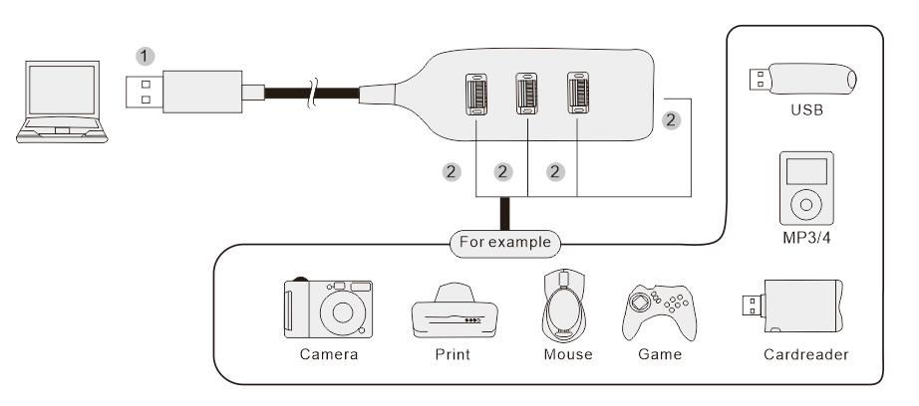

Part number: USB-H41
Barcode number: 8400800017017
Weight: 0.048 kg

